**Name**: Ninad Chavan  
**Roll No**: 281036  
**Batch**: A2

**Assignment 6**

**Statement**

**Q.** Download the **temperatures dataset** from the following link:  
[Temperatures of India Dataset](https://www.kaggle.com/datasets/venky73/temperatures-of-india)

The dataset contains **month-wise average temperatures across India** in Celsius.

**Tasks:**

a) Apply **Linear Regression** using a suitable library function to predict month-wise temperature  
b) Assess the performance of regression models using **MSE**, **MAE**, and **R-Square** metrics  
c) **Visualize** a simple regression model

**Objective**

This assignment helps in understanding:

1. The application of **Linear Regression**.
2. How to make **predictions** using linear models.
3. How to evaluate model performance with suitable metrics.

**Resources Used**

* **Software**: Python 3.x, Google Colab
* **Libraries**: NumPy, Matplotlib, Scikit-learn

**Introduction to Linear Regression**

1. **Linear Regression** is a statistical method for modeling relationships between variables.
2. It is mainly used to **predict continuous numeric outcomes**.
3. The method finds a **best-fit line** representing the relationship between an **independent variable (X)** and a **dependent variable (Y)**.

**Types of Linear Regression**

* **Simple Linear Regression**: Uses a single feature to predict the target variable.
* **Multiple Linear Regression**: Uses multiple features for prediction.

**Applications of Simple Linear Regression**

1. **Predicting student grades** based on study hours.
2. **Estimating agricultural yield** based on rainfall.
3. **Forecasting salary** based on years of experience.

**Limitations of Simple Linear Regression**

1. Assumes a **linear** relationship between features.
2. **Sensitive to outliers**, which can distort predictions.
3. **Does not imply causation**, only correlation.

**Methodology**

1. **Import Libraries**: Load NumPy, Pandas, Matplotlib, and Scikit-learn.
2. **Data Collection**: Load the temperature dataset.
3. **EDA & Preprocessing**:
   * Check for missing values
   * Visualize monthly trends
4. **Data Splitting**:
   * Use train_test_split to divide data into training and testing sets
5. **Model Training**:
   * Use LinearRegression() to train on the data
6. **Predictions**:
   * Predict temperatures for the test set
7. **Model Evaluation**:
   * Calculate **Mean Squared Error (MSE)**
   * Calculate **Mean Absolute Error (MAE)**
   * Compute **R² Score**

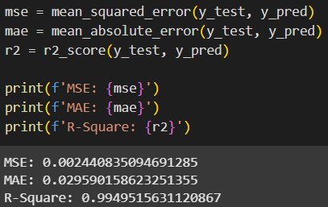**Results**

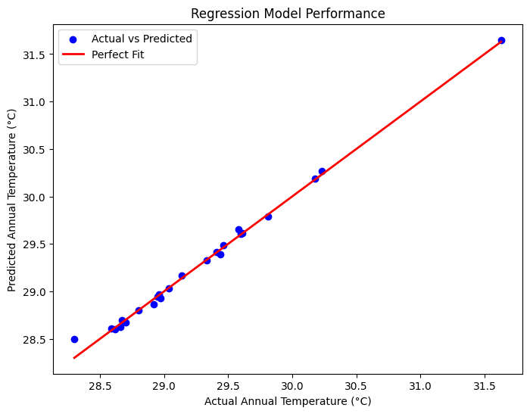

**Conclusion**

A **simple linear regression model** successfully captures the **linear relationship** between month and average temperature in India. While simple and interpretable, such models serve as a foundation for more complex regression-based forecasting in domains like **weather analysis**, **agriculture**, and **finance**.